**KERNEL CONFIGURATION ASSIGNMNET**

OS LAB, BSE-4B

K20-1052

S.M.HASSAN ALI

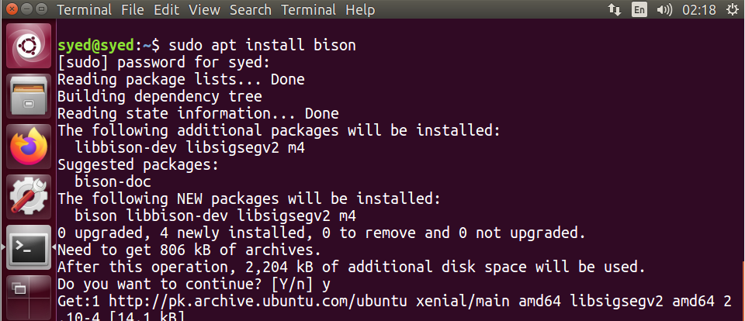1- Install all the dependencies before generating system call.

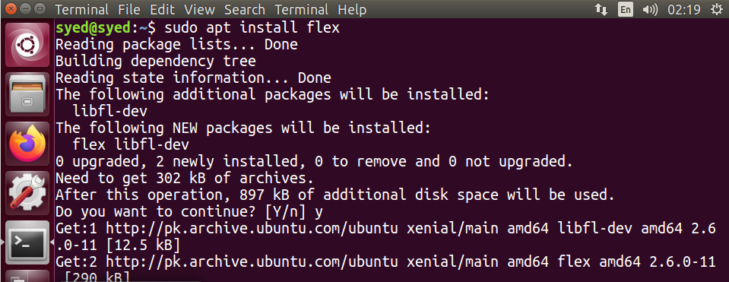

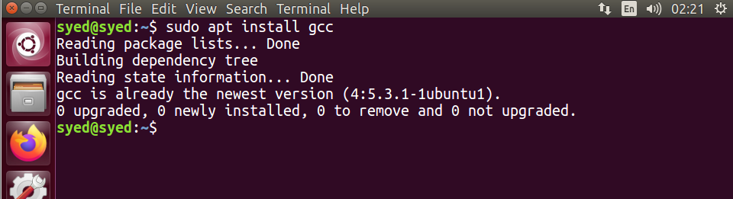

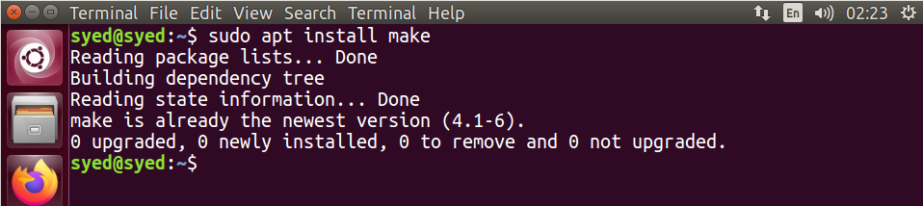

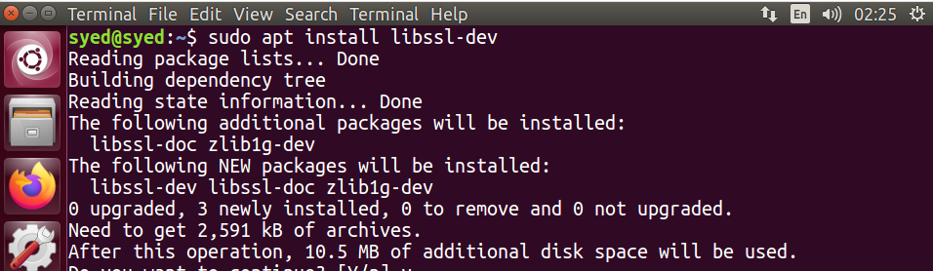

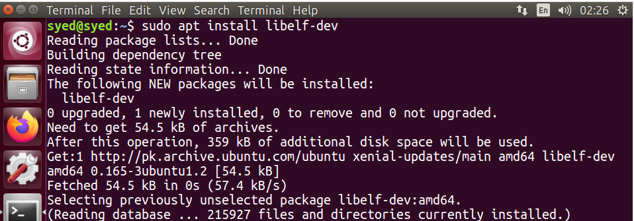

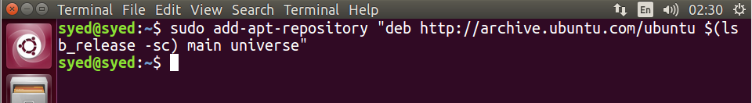

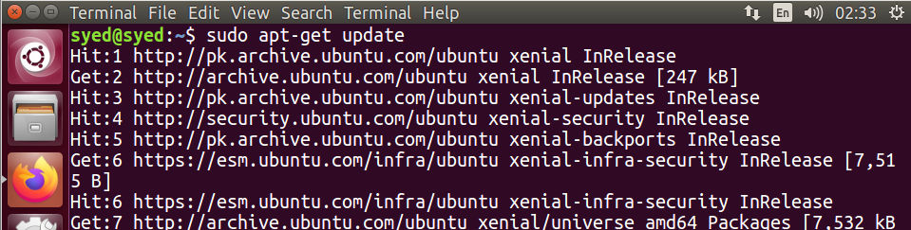

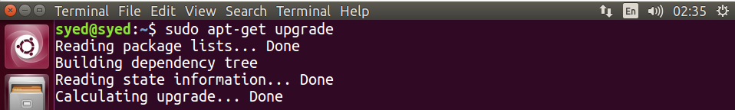

2- Download the new kernel version (**the current one is 4.15.0**) from <https://kernel.org> and extract the file.

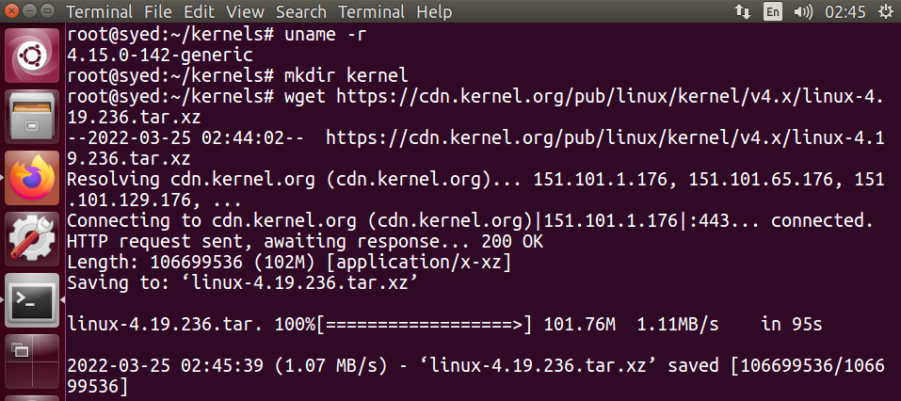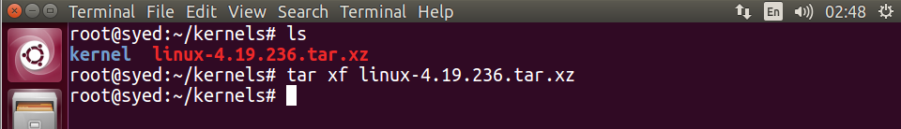

3- After extracting, create a directory where you have to create a c code file of a system call that has to be implemented later on.

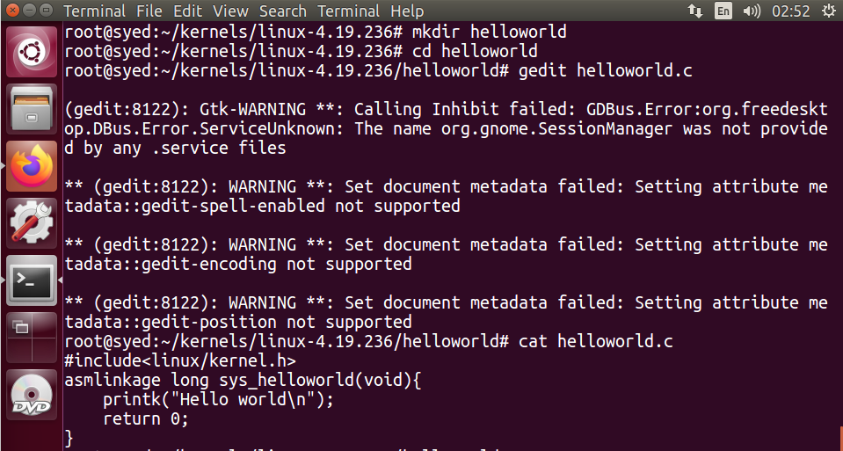

4- Create a new file with ‘**Makefile**’ name and write this.

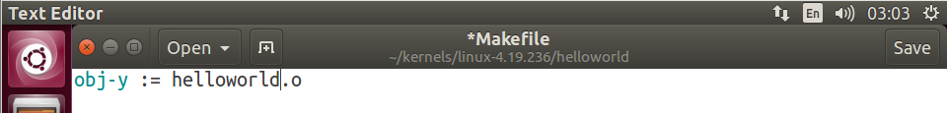

5- Then go to the directory of syscalls and open **syscall_64.tbl** to add system call of sys_helloworld. (remember the line where you have added the code here it is **335**).

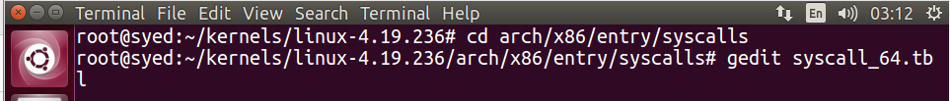

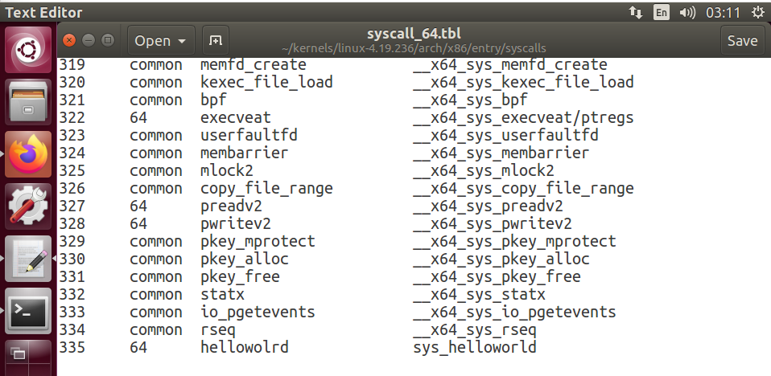

6- Open **Makefile** in the directory of the downloaded kernel and write roll no in **Extraversion** and name in **NAME**.

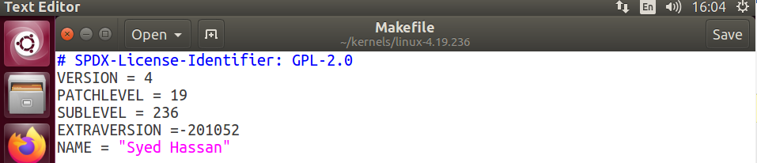

Search for ‘**core-y’**, then add helloworld folder there.

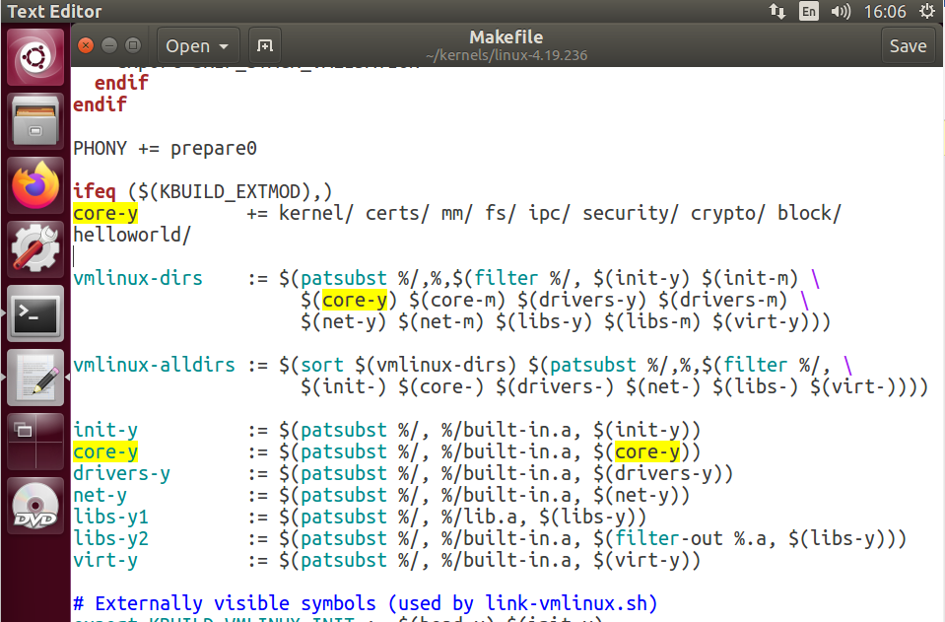

7- Copying old kernel to the newer directory of kernel.

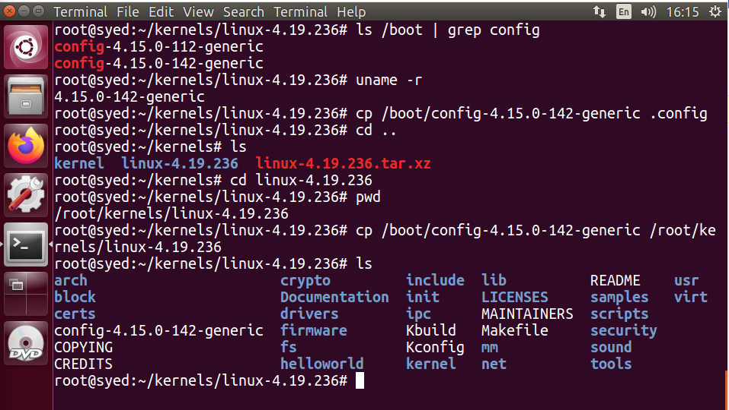

8- Now make old configurations by typing the command ‘**yes ‘’ | grep oldconfig -j4**’ (using j4 since I have allocated 4 cores to my vm).

After, making old configurations, run **‘clean j4’**.

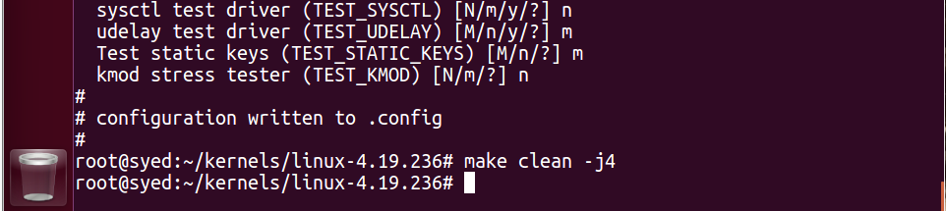

9- Afterwards, install all the modules by running ‘**make modules_install install**’. Once all the modules are installed, the system will display **‘done’**.

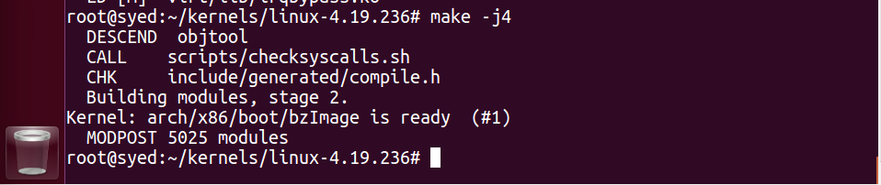

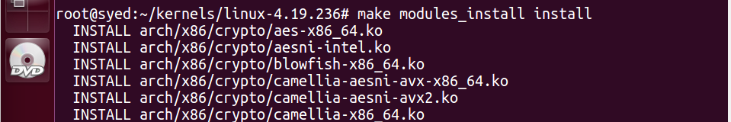

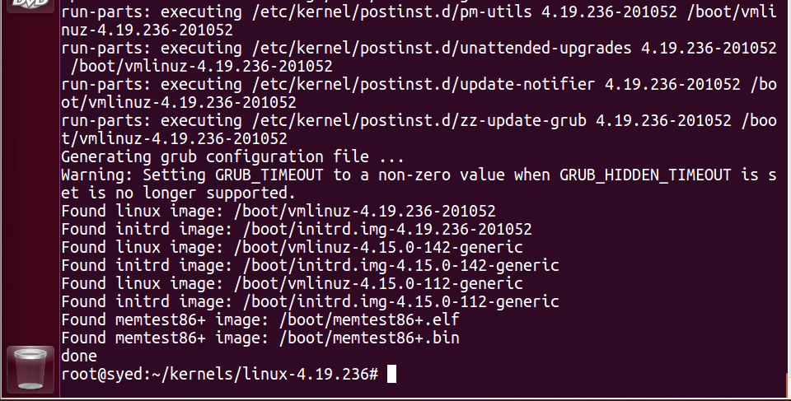

10- Check the name of the new kernel by running “**uname -r**” command

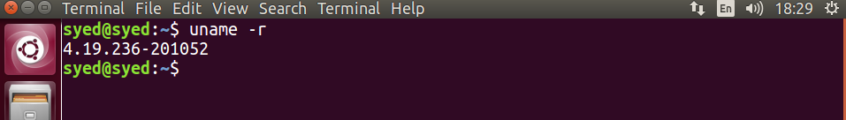

12- Write this code that will trigger system call using that **number** where you placed system call in **Makefile**.

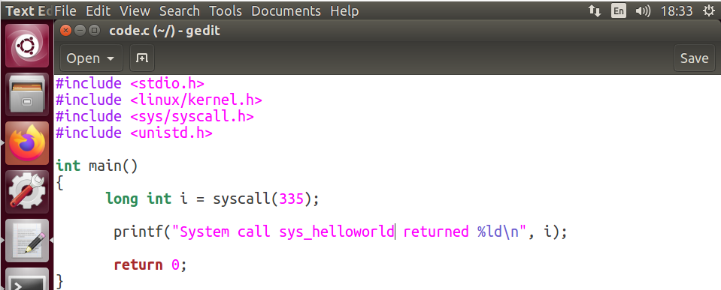

13- Compile and run the code. Output 0 shows it has successfully run.

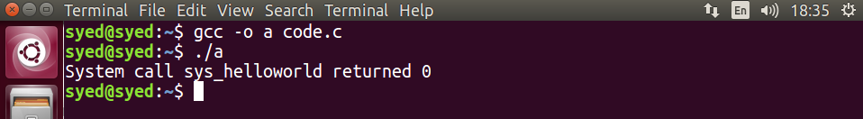

14- Type ‘demesg’ to check the system call **hello world.**

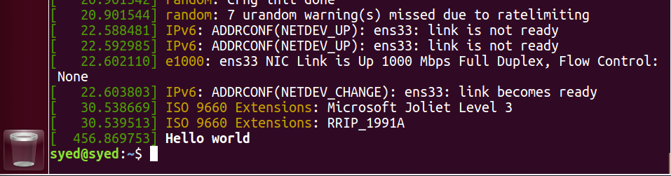

Note:

Spent almost 20 hours doing kernel assignments, was doing in Ubuntu 21 but it kept showing new errors each new one during compilation. So Ubuntu 16 or 17 is preferable for generating system calls since it has no major security protocols.